35.33: Both rays, the one reflected from the pit and the one reflected from the flat region between the pits, undergo the same phase change due to reflection. The condition for destructive interference is 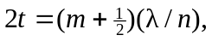 where is the refractive index of the plastic substrate. The minimum thickness is for 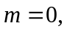 and equals

